URL: https://adityabirlahospital.com/blogs/breast-cancer-awareness-month
Meta Title: Breast Cancer Awareness Month 2025 | Aditya Birla Memorial Hospital
Meta Description: Understand the purpose of Breast Cancer Awareness Month, its history, key symptoms, screening importance, and lifestyle tips for prevention.
H1: Breast Cancer Awareness Month 2025: What it is and Why it Matters?
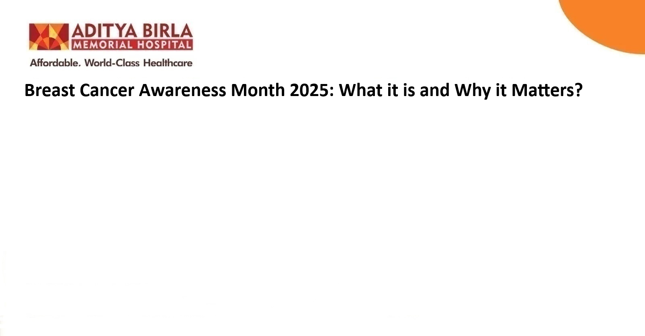
Breast cancer is recognised as one of the most commonly diagnosed cancers among women worldwide. In 2020, it accounted for nearly one in four cancer cases among women globally.
While many efforts have been made to raise awareness, a significant number of cases still reach hospitals at an advanced stage.
This delay in diagnosis is especially pronounced among younger women who often remain outside screening programmes and health policy priorities. The purpose of Breast Cancer Awareness Month is to change that outcome by promoting year-round dialogue, early detection, and targeted education that empower women of all ages to act early.
What is Breast Cancer Awareness Month?
Breast Cancer Awareness Month is a global campaign held every October. It is designed to educate the public about the importance of breast cancer screening, early diagnosis, and timely treatment.
First observed in the United States in 1985, this campaign has since become a worldwide initiative. It encourages individuals, communities, and health institutions to focus on ways to reduce the burden of breast cancer through better access to care and widespread awareness.
The pink ribbon often symbolises the movement. Over time, this symbol has grown to represent solidarity with individuals affected by breast cancer. Many hospitals, support groups, and awareness organisations use it to unify their messaging and outreach during October.
Why Breast Cancer Awareness Matters?
The importance of breast cancer awareness lies in its ability to improve survival outcomes through early detection. Many women, especially those under the age of 40, may not associate themselves with cancer risk. This misconception often leads to delays in diagnosis. Younger women diagnosed with breast cancer frequently present with aggressive subtypes and more advanced disease stages.
Efforts to promote awareness must therefore be tailored to address these knowledge gaps. Continuous education helps women recognise early symptoms of breast cancer and understand the need for timely screening. It also informs people about different types of cancer and the importance of routine health checks.
Awareness campaigns also indirectly affect how society views cancer. They help reduce stigma, foster openness, and create supportive environments where women feel safe seeking help. Awareness is not only about pink ribbons or slogans. It is a critical step towards increasing access to accurate information, regular screenings, and standardised breast cancer treatment pathways.

What Happens During Breast Cancer Awareness Month
During Breast Cancer Awareness Month, the best cancer hospitals in Pimpri-Chinchwad, Pune, and other cities worldwide, healthcare providers, research institutions, advocacy groups, and non-governmental organisations launch various initiatives. These include:
1. Public lectures, webinars, and health fairs that share scientific insights about breast cancer treatment and early detection.
2. Screening drives are organised in hospitals and clinics to improve access to diagnostic tools.
3. Media campaigns that focus on highlighting symptoms of breast cancer in women through visual aids and survivor stories.
4. Fundraisers for research and financial support for patients undergoing treatment.
5. Lighting of public landmarks in pink to visually signal unity in the fight against breast cancer.
While these events play an important role, experts agree that a one-month campaign may not be enough. There is a growing need for sustained, year-round engagement that reaches younger demographics and addresses their unique risk profiles.
Lifestyle Tips for Breast Cancer Prevention
Although not all cases are preventable, certain lifestyle changes may help reduce the risk of breast cancer. These include:
1. Maintaining a healthy body weight through regular physical activity.
2. Avoiding tobacco products and limiting alcohol consumption.
3. Eating a balanced diet rich in fruits, vegetables, and whole grains.

These preventive strategies may not eliminate risk. However, they play a valuable role in reducing overall cancer risk and supporting general health.
Key Symptoms and Screening for Breast Cancer in Women
Knowing the early symptoms of breast cancer in women may allow for faster diagnosis and better outcomes. Some key symptoms include:
1. A new lump in the breast or underarm.
2. Swelling, dimpling, or a change in the breast shape.
3. Pain in the breast that does not go away.
4. Redness or flaky skin around the nipple area.
5. Nipple discharge that is not breast milk.
Screening is the process of identifying cancer before symptoms develop. It often incorporates mammography and clinical breast exams. Regular breast cancer screening assists in detecting the disease at earlier stages (making treatment more successful). Women should consult healthcare providers to understand when to begin screening, especially if they have a family history or genetic risk factors.
Conclusion
Breast Cancer Awareness Month serves as a reminder to prioritise health, seek timely information, and take steps towards early detection. While it has helped normalise conversations around breast cancer, there is a pressing need to extend awareness efforts beyond October. Empowering younger women, reducing stigma, and improving access to screening are essential goals that must be pursued all year.

Frequently Asked Questions (FAQs)

1. What is Breast Cancer Awareness Month, and when is it observed?
Breast Cancer Awareness Month is observed every October to educate people about the prevention, early diagnosis, and treatment of breast cancer across different age groups.
2. Who is most at risk of developing breast cancer?
Women above 50 are at higher risk, although breast cancer in young women has also increased. Genetic factors, lifestyle, and reproductive history may influence individual risk levels.
3. How often should women go for breast cancer screening?
Women should follow personalised screening plans based on age and risk. Regular mammograms are advised for those aged 40 and above unless a doctor suggests earlier screening.
4. Can breast cancer occur in men?
Yes. Although less common, breast cancer may occur in men. It often goes unnoticed until later stages due to low awareness and the absence of routine male breast screening.
5. How does early detection improve survival rates in breast cancer?
Early detection allows for simpler treatment options and improved management. It may lead to better outcomes and reduce the need for aggressive interventions later in the disease. Therefore, visit the best oncologists in Pimpri-Chinchwad, Pune, or other cities if you suspect any of the symptoms.

